Experiment-1
ATM Application
Aim:

To create a UML diagram of ATM Application.

Problem statement:
S/w system is to be designed for supporting a computerized ATM banking n/w.All the accounts maintained in the bank and also the transactions effected,including ATM transactions ,are to be processed by the computers in the bank.
An ATM accepts a relevant cash card interacts with the user,communicates with the central system to carry out the transaction,dispenses cash,and print receipts.
The system to be designed and implemented must include appropriiate record keeping and security provisions.The system must handle concurrent accesses to the same account.
Identification of actors and use cases:
Identification of Use Cases:
View balance
With drawl money
Deposit funds
Transfer funds
Express withdraw
Authenticate customer
Identification of Actors:
Customer
System

USECASE DIAGRAM FOR ATM MANAGEMENT SYSTEM:
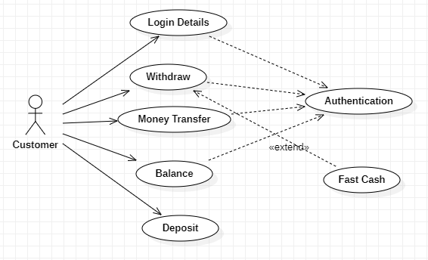
CLASS DIAGRAM FOR ATM MANAGEMENT SYSTEM:
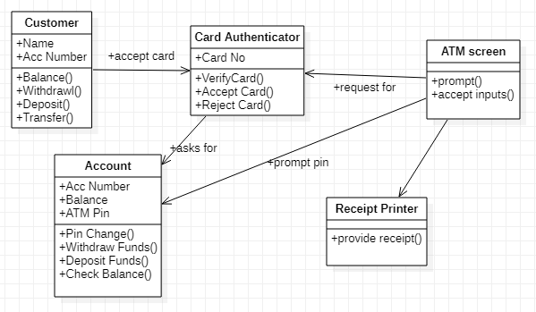
SEQUENCE DIAGRAM FOR WITHDRAWL MONEY:
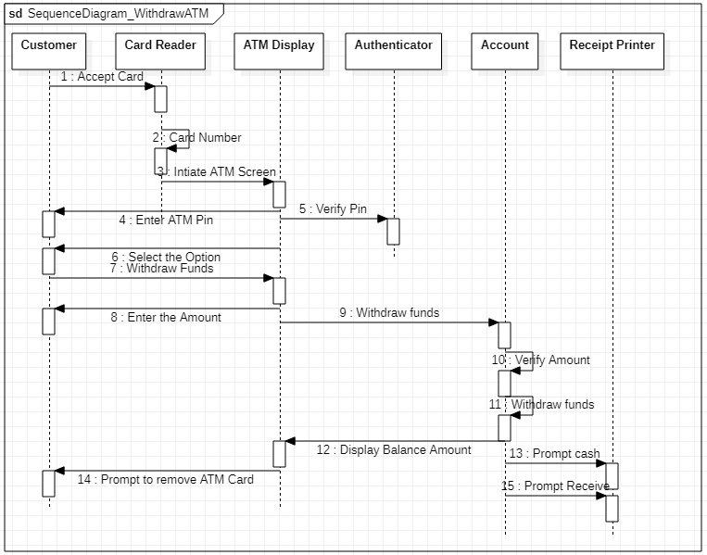
COLLABORATION DIAGRAM FOR WITHDRAWL MONEY:
SEQUENCE DIAGRAM FOR DEPOSIT FUNDS:
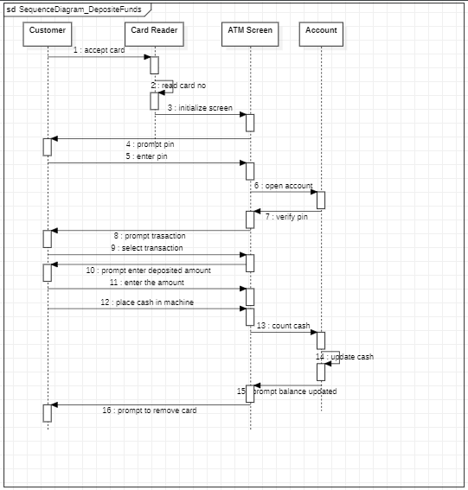
COLLABORATION DIAGRAM FOR DEPOSIT FUNDS:

ACTIVITY DIAGRAM FOR WITHDRAWL MONEY:
ACTIVITY DIAGRAM FOR DEPOSIT MONEY:

COMPONENT DIAGRAM FOR ATM MANAGEMENT SYSTEM:

DEPLOYMENT DIAGRAM FOR ATM MANAGEMENT SYSTEM:

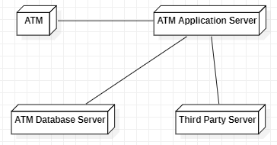

EXPERIMENT-2
Library Management System
Aim:

To create a UML diagram of Library Management System.

Introduction:
Unified Library Application System emphasizes on the online reservation, issue and return of books. This system globalizes the present library system. Using this application, the member can reserve any book from anywhere in the world. Still in nascent stages, this application soon revolutionizes present library system.

USECASE DIAGRAM:

Use case diagram is created to visualize the interaction of our system with the outside world. The components of use case diagram are:
Use Case: Scenarios of the system
Actor: Someone or something who is interacting with the system
Relationship: Semantic link between use case and actor. The forms of relationship are:
Association, Dependency, Generalization
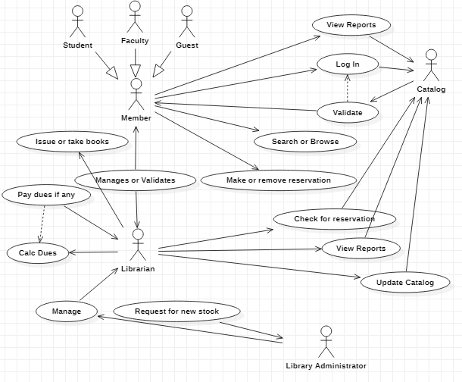

ACTIVITY DIAGRAM:
Activity diagram shows the flow of events within our system.
The components are:
- Start State
- End State
- Transition
- Decision Box
- Synchronization Bar
- Swim Lane
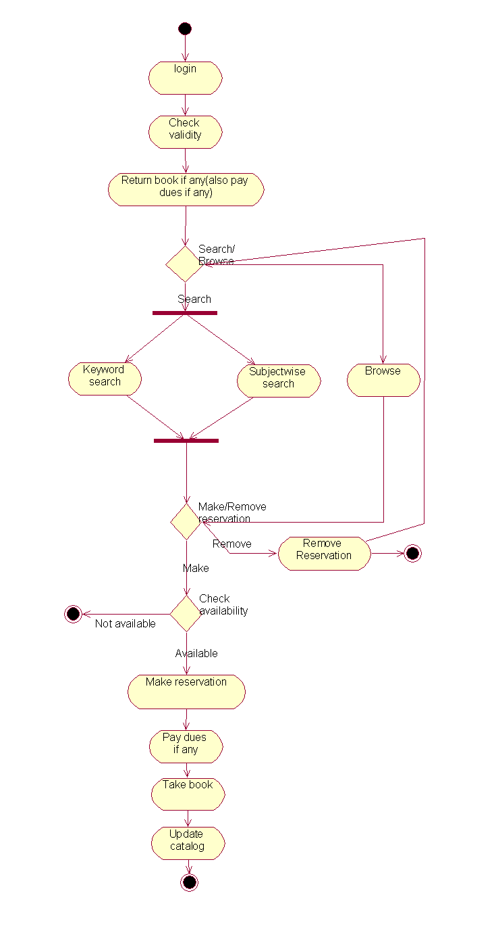
SEQUENCE DIAGRAM:
Sequence diagram shows the step to step what mush happen to accomplish a piece of functionality provided by the system. The components are:
- Actor
- Object
- Messages
- Lifeline
- Focus of Control
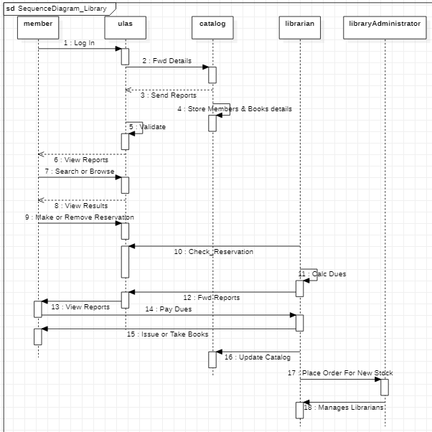

COLLABORATION DIAGRAM:
Collaboration diagram displays object interactions organized around objects and their links to one another. The components are:
- Actor
- Object
- Link

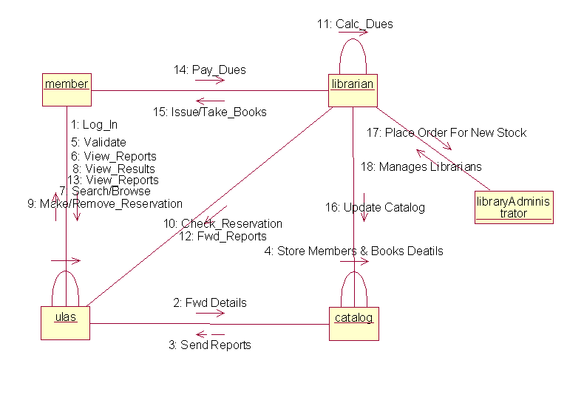CLASS DIAGRAM:
Class diagram shows structure of the software system. The class diagram shows a set of classes, interfaces and their relationships. The components are:
- Class
- Relationship: The forms of relationship are:
Association, Aggregation, Generalization, Composition, Dependency
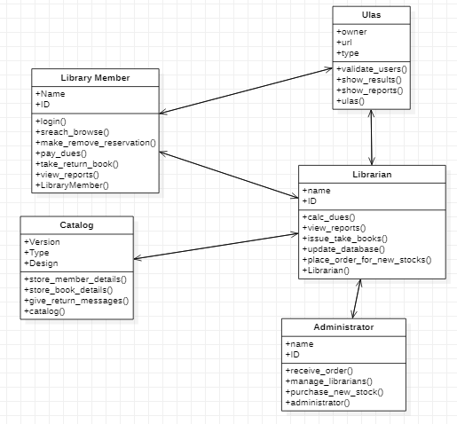

STATE CHART DIAGRAM:
State chart diagram show a life cycle of a single class. The state is a condition where the object may be in. The components are:
- Start state
- End state
- State
- Transition

Member: Librarian: Library Administrator:

EXPERIMENT-3
Abstract Factory Design Pattern
Aim:

To design Abstract Factory Design Pattern.

Intent
Provide an interface for creating families of related or dependent objects without Specifying their concrete classes.
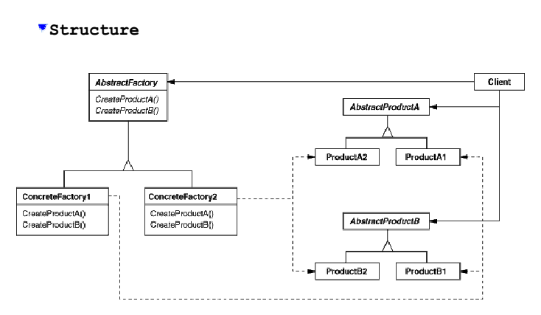

Motivation
Consider a user interface toolkit that supports multiple look- and-feel standards, such as Motif and Presentation Manager. Different look-and-feels define different appearances and behaviours for user interface "widgets" like scroll bars, windows, and buttons. To be portable across look-and-feel standards, an application should not hard-code its widgets for a particular look and feel. Instantiating look-and-feel - specific classes of widgets throughout the application makes it hard to change the look and feel later. We can solve this problem by defining an abstract Widget Factory class that declares anointer face for creating each basic kind of widget. There's also an abstract class for each kind of widget, and concrete subclasses implement widgets for specific look-and-feel standards. Widget Factory’s interface has an operation that returns a new widget object for each abstract widget class. Clients call these operations to obtain widget instances, but clients aren’t aware of the concrete classes they're using. Thus clients stay independent of the prevailing look and feel.

SOLUTION:

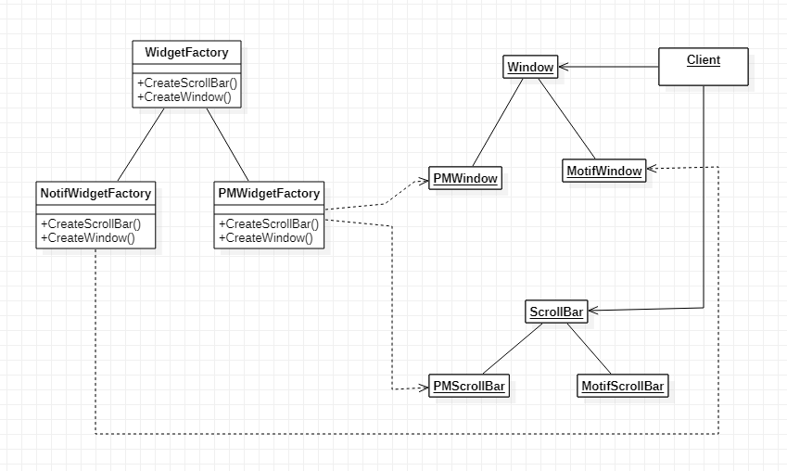

Participants:

AbstractFactory (WidgetFactory)
declares an interface for operations that create abstract product
objects.

ConcreteFactory (MotifWidgetFactory, PMWidgetFactory)
implements the operations to create concrete product objects.

AbstractProduct (Window, ScrollBar)
declares an interface for a type of product object.

ConcreteProduct (MotifWindow, MotifScrollBar)
defines a product object to be created by the corresponding concrete
factory. implements the AbstractProduct interface.

Client
uses only interfaces declared by AbstractFactory and
AbstractProduct classes.

EXPERIMENT-4
Builder Design Pattern

Aim:

To design Builder Design Pattern.

Intent:

Separate the construction of a complex object from its representation so that
the same construction process can create different representations.

Structure:

Motivation:

A reader for the RTF (Rich Text Format) document exchange format should be able to convert RTF to many text formats. The reader might convert RTF documents into plain ASCII text or into a text widget that can be edited interactively. The problem, however, is that the number of possible conversions is open-ended. So it should be easy to add a new conversion without modifying the reader. A solution is to configure the RTF Reader class with a Text Converter object that converts RTF to another textual representation. As the RTF Reader parses the RTF document, it uses the Text Converter to perform the conversion. Whenever the RTF Reader recognizes an RTF token (either plain text or an RTF control word), it issues a request to the Text Converter to convert the token. Text Converter objects are responsible both for performing the data conversion and for representing the token in a particular format. Subclasses of Text Converter specialize in different conversions and formats. For example, an ASCII Converter ignores requests to convert anything except plain text. A TeX Converter, on the other hand, will implement operations for all requests in order to produce a TeX representation that captures all the stylistic information in the text. A Text Widget Converter will produce a complex user interface object that lets the user see and edit the text.

SOLUTION:

Participants:

Builder (TextConverter)
specifies an abstract interface for creating parts of a Product
object.

ConcreteBuilder (ASCIIConverter, TeXConverter, TextWidgetConverter)
constructs and assembles parts of the product by implementing the
Builder interface. defines and keeps track of the representation it creates.
provides an interface for retrieving the product (e.g., GetASCIIText,
GetTextWidget).

Director (RTFReader)
constructs an object using the Builder interface.

Product (ASCIIText, TeXText, TextWidget)
represents the complex object under construction. ConcreteBuilder builds the product's internal representation and defines the process by which it's assembled. includes classes that define the constituent parts, including
interfaces for assembling the parts into the final result.

EXPERIMENT-5
Facade Design Pattern
Aim:

To design Facade Design Pattern.

Intent:
Provide a unified interface to a set of interfaces in a subsystem. Facade defines
a higher-level interface that makes the subsystem easier to use.
Structure:
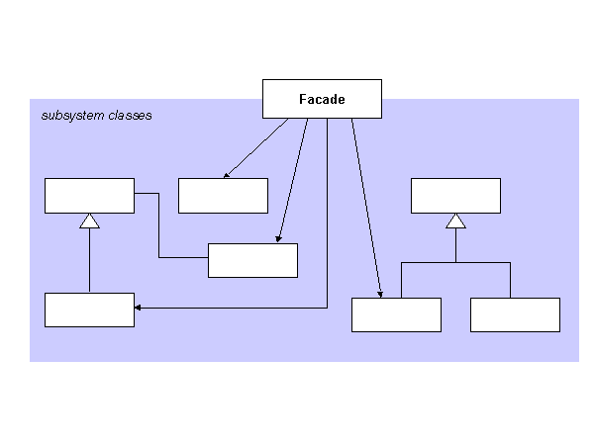Motivation:
Structuring a system into subsystems helps reduce complexity. A common design goal is to minimize the communication and dependencies between subsystems. One way to achieve this goal is to introduce a facade object that provides a single, simplified interface to the more general facilities of a subsystem.

Consider for example a programming environment that gives applications access to its compiler subsystem. This subsystem contains classes such as Scanner, Parser, Program Node, Bytecode Stream, and Program Node Builder that implement the compiler. Some specialized applications might need to access these classes directly. But most clients of a compiler generally don't care about details like parsing and code generation; they merely want to compile some code. For them, the powerful but low-level interfaces in the compiler subsystem only complicate their task. To provide a higher-level interface that can shield clients from these classes, the compiler subsystem also includes a Compiler class.
This class defines a unified Interface to the compiler's functionality. The Compiler class acts as a facade: It offers clients a single, simple interface to the compiler subsystem. It glues together the classes that implement compiler functionality without hiding them completely. The compiler facade makes life easier for most programmers without hiding the lower-level functionality from the few that need it.

SOLUTION:

Participants:

· Facade (Compiler)
knows which subsystem classes are responsible for a request.
delegates client requests to appropriate subsystem objects.

· Subsystem classes (Scanner, Parser, Program Node, etc.)
implement subsystem functionality. handle work assigned by the Facade object. have no knowledge of the facade; that is, they keep no references to it

EXPERIMENT- 6
Bridge Design Pattern

Aim:

To design Bridge Design Pattern.

Intent:

Decouple an abstraction from its implementation so that the two can vary independently.

Structure:

Motivation:

When an abstraction can have one of several possible implementations, the usual way to accommodate them is to use inheritance. An abstract class defines the interface to the abstraction, and concrete subclasses implement it in different ways. But this approach isn't always flexible enough. Inheritance binds an implementation to the abstraction permanently, which makes it difficult to modify, extend, and reuse abstractions and implementations independently. Consider the implementation of a portable Window abstraction in a user interface toolkit. This abstraction should enable us to write applications that work on both the X Window System and IBM's Presentation Manager (PM), for example. Using inheritance, we could define an abstract class Window and subclasses XWindow and PMWindow that implement the Window interface for the different platforms.

SOLUTION:

Participants:

Abstraction (Window)
defines the abstraction's interface. maintains a reference to an object of type Implementor.

RefinedAbstraction (IconWindow)
Extends the interface defined by Abstraction.

Implementer (WindowImp)
Defines the interface for implementation classes. This interface doesn't have to correspond exactly to Abstraction's interface; in fact, the two interfaces can be quite different. Typically, the Implementer interface provides only primitive operations, and Abstraction defines higher-level operations based on these primitives.

ConcreteImplementor (XWindowImp, PMWindowImp)
implements the Implementor interface and defines its concrete
implementation.

EXPERIMENT-7
Decorator Design Pattern

Aim:

To design Decorator Design Pattern.

Intent:

Attach additional responsibilities to an object dynamically. Decorators provide a flexible alternative to sub classing for extending functionality.

Structure:

Motivation:

Sometimes we want to add responsibilities to individual objects, not to an entire class. A graphical user interface toolkit, for example, should let you add properties like borders or behaviours like scrolling to any user interface component. One way to add responsibilities is with inheritance. Inheriting a border from another class puts a border around every subclass instance. This is inflexible, however, because the choice of border is made statically. A client can't control how and when to decorate the component with a border. A more flexible approach is to enclose the component in another object that adds the border. The enclosing object is called a decorator. The decorator conforms to the interface of the component it decorates so that its presence is transparent to the component's clients. The decorator forwards requests to the component and may perform additional actions (such as drawing a border) before or after forwarding. Transparency lets you nest decorators recursively, thereby allowing an unlimited number of added responsibilities. For example, suppose we have a TextView object that displays text in a window. TextView has no scroll bars by default, because we might not always need them. When we do, we can use a ScrollDecorator to add them. Suppose we also want to add a thick black border around the TextView. We can use a BorderDecorator to add this as well. We simply compose the decorators with the TextView to produce the desired result.

SOLUTION:

Participants:

Component (VisualComponent)
defines the interface for objects that can have responsibilities
added to them dynamically.

ConcreteComponent (TextView)
defines an object to which additional responsibilities can be
attached.

Decorator
maintains a reference to a Component object and defines an interface
that conforms to Component's interface.

ConcreteDecorator (BorderDecorator, ScrollDecorator)
adds responsibilities to the component.

EXPERIMENT-8
Chain of Responsibility
Aim:

To design Chain of Responsibility Design Pattern.
Intent:
Avoid coupling the sender of a request to its receiver by giving more than one object a chance to handle the request. Chain the receiving objects and pass the request along the chain until an object handles it.
Structure:
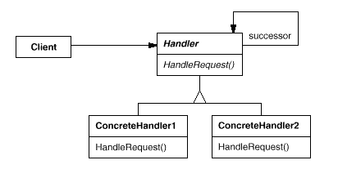
Motivation:
Consider a context-sensitive help facility for a graphical user interface. The user can obtain help information on any part of the interface just by clicking on it. The help that's provided depends on the part of the interface that's selected and its context; for example, a button widget in a dialog box might have different help information than a similar button in the main window. If no specific help information exists for that part of the interface, then the help system should display a more general help message about the immediate context—the dialog box as a whole, for example.
Hence it's natural to organize help information according to its generality—from the most specific to the most general. Furthermore, it's clear that a help request is handled by one of several user interface objects; which one depends on the context and how specific the available help is.
The problem: The object that ultimately provides the help isn't known explicitly to the object (e.g., the button) that initiates the help request. What we need is a way to decouple the button that initiates the help request from the objects that might provide help information.
Solution: The Chain of Responsibility pattern defines how that happens. The idea of this pattern is to decouple senders and receivers by giving multiple objects a chance to handle a request. The request gets passed along a chain of objects until one of them handles it.
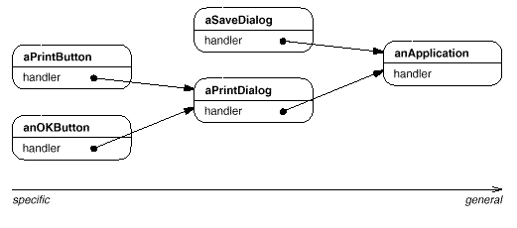
The first object in the chain receives the request and either handles it or forwards it to the next candidate on the chain, which does likewise. The object that made the request has no explicit knowledge of who will handle it-we say the request has an implicit receiver.
Let's assume the user clicks for help on a button widget marked "Print." The button is contained in an instance of PrintDialog, which knows the application object it belongs to (see preceding object diagram). The following interaction diagram illustrates how the help request gets forwarded along the chain:
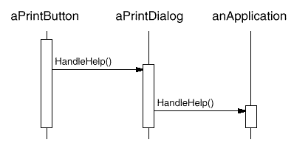
In this case, neither aPrintButton nor aPrintDialog handles the request; it stops at anApplication, which can handle it or ignore it. The client that issued the request has no direct reference to the object that ultimately fulfills it. To forward the request along the chain, and to ensure receivers remain implicit, each object on the chain shares a common interface for handling requests and for accessing its successor on the chain. For example, the help system might define a HelpHandler class with a corresponding HandleHelp operation. HelpHandler can be the parent class for candidate object classes, or it can be defined as a mixin class. Then classes that want to handle help requests can make HelpHandler a parent:
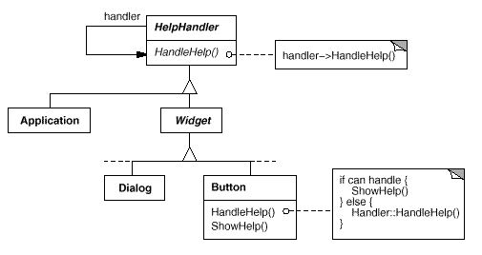
The Button, Dialog, and Application classes use HelpHandler operations to handle help requests. HelpHandler's HandleHelp operation forwards the request to the successor by default. Subclasses can override this operation to provide help under the right circumstances; otherwise they can use the default implementation to forward the request.
Participants:
- Handler(HelpHandler)
  - defines an interface for handling requests
  - (optional) implements the successor link

- ConcreteHandler(PrintButton, PrintDialog)
  - Handles requests it is possible for.
  - Can access its successor
  - if the ConcreteHandler can handle the request, it does so; otherwise it forwards the request to its successor.
- Client
  - Initiates the request to a ConcreteHandler object of the chain.

EXPERIMENT-9
Visitor

Aim:

To design Visitor Design Pattern.

Intent:

Represent an operation to be performed on the elements of an object structure.
Visitor lets you define a new operation without changing the classes of the elements
on which it operates.

Structure:

Motivation:

Consider a compiler that represents programs as abstract syntax trees. It will need to perform operations on abstract syntax trees for "static semantic" analyses like checking that all variables are defined. It will also need to generate code. So it might define operations for type-checking, code optimization, flow analysis, checking for variables being assigned values before they're used, and so on. Moreover, we could use the abstract syntax trees for pretty-printing, program restructuring, code instrumentation, and computing various metrics of
program. Most of these operations will need to treat nodes that represent assignment
statements differently from nodes that represent variables or arithmetic expressions. Hence there will be one class for assignment statements, another for variable accesses, another for arithmetic expressions, and so on. The set of node classes depends on the language being compiled, of course, but it doesn't change much for a given language.

This diagram shows part of the Node class hierarchy. The problem here is that distributing all these operations across the various node classes leads to a system that's hard to understand, maintain, and change. It will be confusing to have for example, a compiler that didn't use visitors might type-check a procedure by calling the Type Check operation on its abstract syntax tree. Each of the nodes would implement Type Check by calling TypeCheckon its components (see the preceding class diagram). If the compiler type-checked a procedure using visitors, then it would create a TypeCheckingVisitor object and call the Accept operation on the abstract syntax tree with that object as an argument. Each of the nodes would implement Accept by calling back on the visitor: an assignment node calls Visit Assignment operation on the visitor, while a variable reference calls Visit Variable Reference. What used to be the Type Check operation in class Assignment Node is now the Visit Assignment operation on Type Checking Visitor. To make visitors work for more than just type-checking, we need an abstract parent class Node Visitor for all visitors of an abstract syntax tree. Node Visitor must declare an operation for each node class. An application that needs to compute program metrics will define new subclasses of Node Visitor and will no longer need to add application-specific code to the node classes. The Visitor pattern encapsulates the operations for each compilation phase in a Visitor associated with that phase.

SOLUTION:

Participants:

Visitor (Node Visitor)
Declares a Visit operation for each class of ConcreteElement in the object structure. The operation's name and signature identifies the class that sends the Visit request to the visitor. That lets the visitor determine the concrete class of the element being visited.
Then the visitor can access the element directly through its particular interface.

Concrete Visitor (TypeCheckingVisitor)
Implements each operation declared by Visitor. Each operation implements a fragment of the algorithm defined for the corresponding class of object in the structure. Concrete Visitor provides the context for the algorithm and stores its local state. This state often accumulates results during the traversal of the structure.

Element (Node)
Defines an Accept operation that takes a visitor as an argument.

Concrete Element (AssignmentNode,VariableRefNode)

Object Structure (Program)
Can enumerate its elements.
May provide a high-level interface to allow the visitor to visit its elements.
May either be a composite (see Composite (183)) or a collection such as a list or a set.

Collaborations
A client that uses the Visitor pattern must create a Concrete Visitor object and then traverse the object structure, visiting each element with the visitor.
When an element is visited, it calls the Visitor operation that corresponds to its class. The element supplies itself as an argument to this operation to let the visitor access its state, if necessary.
The following interaction diagram illustrates the collaborations between
an object structure, a visitor, and two elements:

EXPERIMENT-10
Iterator

Aim:

To design Iterator Design Pattern.

Intent:

Provide a way to access the elements of an aggregate object sequentially without exposing its underlying representation.

Also Known as:

Cursor

Structure:

Motivation:

An aggregate object such as a list should give you a way to access its elements without exposing its internal structure. Moreover, you might want to traverse the list in different ways, depending on what you want to accomplish. But you probably don't want to bloat the List interface with operations for different traversals, even if you could anticipate the ones you will need. You might also need to have more than one traversal pending on the same list.
The Iterator pattern lets you do all this. The key idea in this pattern is to take the responsibility for access and traversal out of the list object and put it into an iterator object. The Iterator class defines an interface for accessing the list's elements. An iterator object is responsible for keeping track of the current element; that is, it knows which elements have been traversed already.
For example, a List class would call for a List Iterator with the following relationship between them:

We define an Abstract List class that provides a common interface for manipulating lists. Similarly, we need an abstract Iterator class that defines a common iteration interface. Then we can define concrete Iterator subclasses for the different list implementations. As a result, the iteration mechanism becomes independent of concrete aggregate classes.

SOLUTION:

Participants:

Iterator
Defines an interface for accessing and traversing elements.

Concrete Iterator
Implements the Iterator interface. Keeps track of the current position in the traversal of the aggregate.

Aggregate
Defines an interface for creating an Iterator object.

Concrete Aggregate
Implements the Iterator creation interface to return an instance of the proper Concrete Iterator.

EXPERIMENT-11
Document Editor

Aim:

To design a Document Editor.

Document Editor:

Requirements Specification:

1. Document Structure: Treat characters, lines, rows and columns uniformly.
2. Formatting: It should be possible to dynamically switch between different formatting algorithms.
3. Embellish the user interface in a very flexible and dynamic way.
4. Support multiple look and feel standards: Lexi should easily adapt to multiple look and feel standards like Motif, PM etc.
5. Support multiple windowing systems: Lexi should be independent of the windowing systems used.
6. Support flexible user operations.
7. Spell check and hyphenation.

Document Structure:

- A document is an arrangement of basic graphical elements such as characters, lines, polygons and other shapes.
- The basic idea used to compose a document is that of recursive composition.
- Recursive composition is the technique by which we build complex elements out of simpler ones.
- It uses a mix of composition and inheritance.
- For example, a set of characters and graphics are arranged to form a row, multiple rows are arranged to form a column, multiple columns can form a page and so on.
- The design pattern, Composite captures the essence of recursive composition in object-oriented terms.
- We define an abstract class, Glyph, to represent all the objects that can appear in a document.
- It provides three operations- Draw(Window) draws itself in the window, Intersects(Point) returns checks whether the glyph is intersecting with the point p and Insert(Glyph, int) inserts the Glyph at position 'int'.
- The partial Glyph class hierarchy is shown below. Here Character, Polygon and Rectangle are the leaves and Row represents the composite.

SOLUTION:

